**Aim:** Write a python program to define a module and import a specific function in that module to another program

**IDE:**

Python Modules

As our program grows bigger, it may contain many lines of code. Instead of putting everything in a single file, we can use modules to separate codes in separate files as per their functionality. This makes our code organized and easier to maintain.

Module is a file that contains code to perform a specific task. A module may contain variables, functions, classes etc. Let's see an example,

Let us create a module. Type the following and save it as example.py

def add(a,b):

result = a+b

return result

import example as addition

a = addition.add(4,5)

print(a)

Output

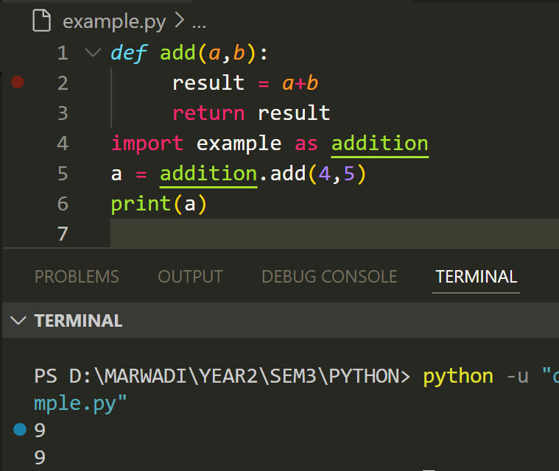

Import Python Standard Library Modules

The Python standard library contains well over 200 modules. We can import a module according to our needs. Suppose we want to get the value of pi, first we import the math module and use math.pi. For example,

#import standard math module

import math

# use math.pi to get value of pi

print("The value of pi is", math.pi)

Output

Python import with Renaming

In Python, we can also import a module by renaming it. For example,

# import module by renaming it

import math as m

print(m.pi)

Output

Python from...import statement

We can import specific names from a module without importing the module as a whole. For example,

# import only pi from math module

from math import pi

print(pi)

Output

Import all names

In Python, we can import all names(definitions) from a module using the following construct:

# import all names from the standard module math

from math import *

print("The value of pi is", pi)

Output

The dir() built-in function

In Python, we can use the dir() function to list all the function names in a module.

We can use dir in math module in the following way:

print(dir(math))

Output

Built-in modules

Some examples of Python built-in modules include “os”, “sys”, “math”, and “datetime”.

help('modules')

Output:

Let’s find the area of the circle

Python Code

Print the values of positive and negative infinity.

**import** math

print (math.inf)

print (**-**math.inf)

Output

List of Mathematical function in Math Module

pow(x,y), sqrt(x), trunc(x), cos(x), sin(x), tan(x), degrees(x), radians(x), exp(x), log2(x), log10(x)

**Post Lab Exercise:**

1. Write a Python program to convert degree to radian

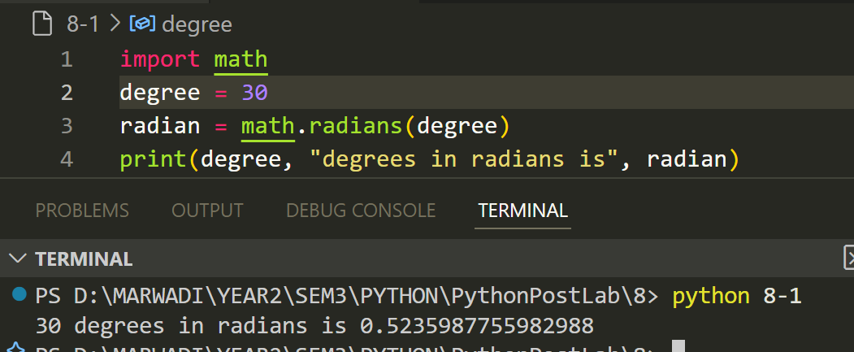

1. Make a simplest possible Python program that calculates and prints the value of the formula

1. Write a Python function that evaluates the mathematical functions

Return these three values. Write out the results of these values for

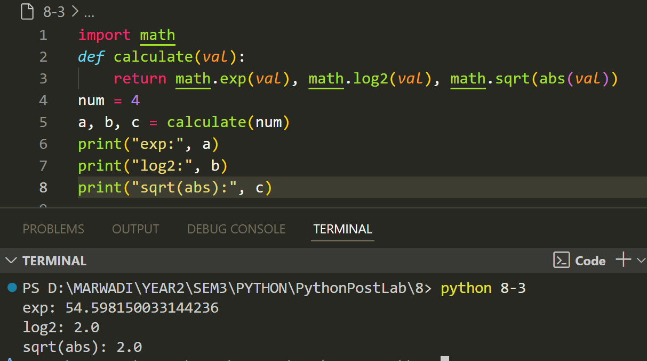

Github : [PythonPostLab/8 at main · Om-Lathigara/PythonPostLab](https://github.com/Om-Lathigara/PythonPostLab/tree/main/8)